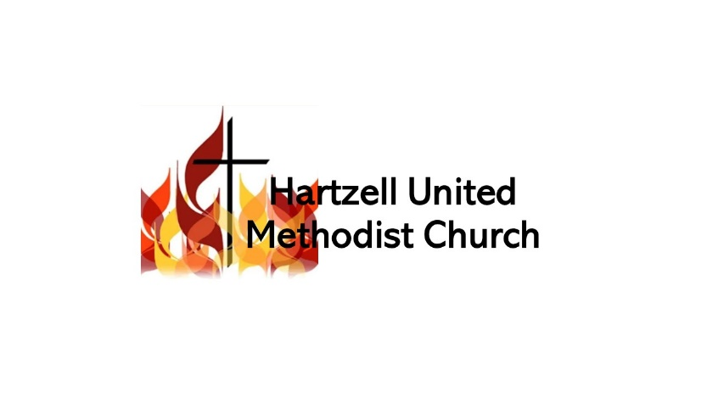
2022 Ministry Catalogue

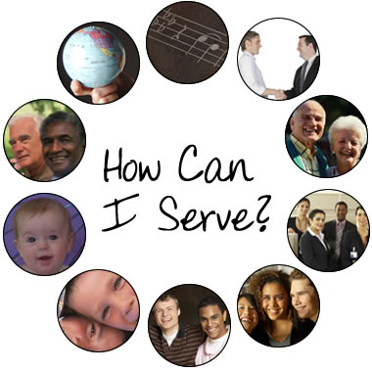
Worship Ministries

Choir: This team provides special music for worship and reflection during our worship service.

Bell Choir: Provides special music for worship and reflection during our worship service.

Special Music: Sing, play an instrument, or dance as a special in our worship service.

Liturgists: Read scripture, lead the call to worship and other special readings during worship.

Acolytes: Light candles for or during our worship service.

Communion Servers: This team assists with setting up, tearing down, and serving communion on the first Sunday of the month.

Decorations Team: This team is responsible for making the sanctuary comfortable, attractive, and conducive for worship through banners, altar displays, paraments, and other decorations.

Media/Sound/Lighting Team: This team builds and runs the PowerPoint presentation for our worship service and sets up and monitors sound and lighting for our worship service.

Online Worship: Assist in producing and publishing our online worship service. Engage with those who are worshipping with us online on Facebook and/or YouTube in the comments.

Worship Planning: Plan worship services and sermon series in conjunction with the pastor.

Drama Team: Offer a brief skit or dramatic monologue/reading as a special in worship.

Hospitality Ministries

Ushers: This team welcomes and assists people in worship by handing out bulletins, collecting the offering, and dismissing people for communion during worship.

Greeters: Warmly greet everyone with a handshake and a smile at the door. These people give first impressions of friendliness, acceptance, and love to members, attenders, and guests alike.

Coffee Hosts: This team is responsible for creating a comfortable and welcoming environment by setting up and cleaning up the coffee and refreshments in the lobby each week.

Prayer Team: Pray for our worship services prior to worship. Pray for our church and its people following worship around the prayer table.

Follow-up: This team follows-up with those who are new to our church or who are missing to provide a sense of care and welcome. Take attendance during worship.
Discipleship Ministries

Children and Family Ministries

Nursery: A team providing dependable, safe, secure, and nurturing care to children (birth to age 2) during our Sunday worship experiences, special services/events, and/or small group events.

Children’s Sunday School: Teachers that provide Christian principles and spiritual direction for children ages 3-grade 6 during our worship services. Background check and training required.

Special Event Leaders: Plan and orchestrate children’s and family-oriented outreach events, such as Vacation Bible School, the Easter Egg Hunt, Trunk or Treat, our Christmas play, etc.

Youth Ministries

Youth Sunday School: Teachers providing Christian principles for youth grades 7-12 during our worship service. Background check and training required.

Youth Group: Leaders and helpers providing Christian teaching, fellowship, and fun for youth grades 5-12. We offer pre-teen and teen groups on the third Sunday after worship. At times, we need chaperones for overnight events or to travel to events off-site. Background check required.

Confirmation Leaders: Teachers who lead 7th-8th grade youth who were baptized as infants through instruction in the meaning of baptism, the Christian faith, and the history, organization, and teachings of the United Methodist Church. Background check and training required.

Adult Discipleship Ministries

Small Group/Bible Study Leaders: Facilitate a small group or Bible study that fosters Christian growth, fellowship, and accountability. Small group leader training required.

Women’s Ministries (formerly United Methodist Women): This group is designed for fellowship, accountability, building relationships, and living life together as Christian women.

Men’s Ministries (formerly United Methodist Men): This group is designed for fellowship, accountability, building relationships, and living life together as Christian men.

Young at Hartz: This group is designed to foster fellowship among older adults.

Online Devotions: Offer daily devotions on our church Facebook page. Training required.

Congregational Care Ministries

Helping Hands: This team prepares and takes meals to shut-ins on Wednesday at 3:30 p.m.

Funeral Dinners: This group provides meals for families who are grieving at funerals.

Visitation Team: Assists the pastor in making calls to shut-ins and those in the hospital.

Outreach Ministries

Welcome Wagon: This team identifies new people moving into our neighborhood and then prepares and delivers gift bags to them each month.

Community Appreciation: This team prepares and delivers gift bags to first responders (fire, police, etc.) and the schools in order to show appreciation for their work in our community.

Block Parties/Cookouts: People who are willing to host a block party or cookout at their home in order to get to know their neighbors for the cause of Jesus Christ on a regular basis. Hartzell provides the food and prizes and marketing. You just need to be to host and build relationships.

Community Outreach: There are always regular opportunities for engagement with the school and the community for the cause of Christ. Our current focus is on a book club at the Reading Library, but if you would like to start something else, please let us know!

Missions Ministries

Missions Committee: This team guides and oversees all the mission projects in the church. They meet after church one Sunday a month. The missions chair serves on the Leadership Board.

Jail Ministry: This team goes into the jail each month to minister to inmates with the love of Jesus Christ. Background check required.

Interfaith Hospitality Ministry/Wesley Foundation: Hartzell regularly makes meals to provide for the needy and college students through the work of these two ministry partners.

Operation Christmas Child/Maslow’s Army/Matthew 25/Festival of Sharing: Hartzell is always collecting items for the homeless, the poor, and the underprivileged in the world. If you would be interested in organizing a collection effort or dropping off collected items let us know.

Mission Trips: There are always regular opportunities for cross-cultural mission trips with the district and the conference, or volunteer to plan one for our church.

Administrative Ministries

Leadership Board: The team tasked with making decisions and providing spiritual direction on behalf of the church. Required roles include Lay Leader, Lay Delegate to Annual Conference, Staff-Pastor Parish Relations Chair, Finance Chair, Treasurer, Board Chair, and Trustee Chair. Approved by Charge Conference to serve in this capacity but let us know if you are interested.

Trustees: This team provides for the general maintenance, appearance, and serviceability of all church property, including the church building, grounds, and the church parsonage.

Counters: This team takes care of counting, sorting, and recording all of the offerings from the weekend in accordance with our finance policy. Background check required.

Communications: This team maintains and keeps our church website and Facebook page.

Administrative Assistants: Performs miscellaneous tasks as requested by the pastor and the office manager.

Fundraising Event Coordinators: Plan and organize one of our many fundraising events throughout the year. Examples include our annul fish fry, rummage sale, or sauerkraut dinner.

Don’t see something that fits you? We would be glad to design a new ministry around you!

